**Student Data Management**

1. Create a database called “LMT_University”.

1. Create an “enrol” schema under “LMT_University”.

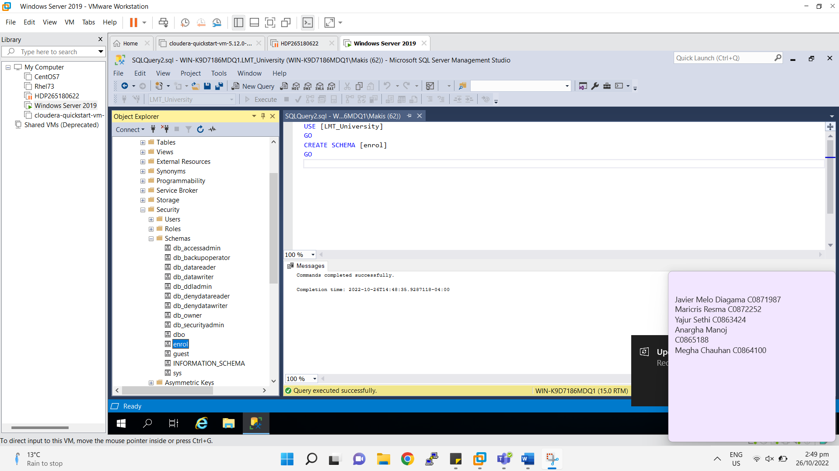

1. Use “enrol” Schema for creating the project.
2. Create the Database modeling in such a way that Model looks like-



1. Create an “Address” table under “enrol” schema with the following specifications-
   1. Address table must have the following attributes-

|  |  |  |
| --- | --- | --- |
| **Column Name** | **Data Type** | **Description** |
| AddressID | Integer | Address Unique Identifier |
| StreetAddress | Varchar | Street Address |
| City | Varchar | City |
| State | Varchar | State |
| PostalCode | Varchar | Zip Code of a particular location |
| Country | Varchar | Country |
| InsertedOn | DateTime | Data Insertion Date |

* 1. Add the following constraint.
     1. AddressID: Auto Increment, Primary Key, Not null, clustered index.
     2. StreetAddress: Null
     3. City: Not Null
     4. State: Null
     5. PostalCode: Null
     6. Country: Not Null
     7. InsertedOn: Not Null
  2. Insert the following records based on the following specifications.
     1. AddressID: Address ID starting from 1 to 30 with step size 1.
     2. StreetAddress: Insert the street Address mentioned in the table.
     3. City: Insert the City mentioned in the table.
     4. State: Insert the State mentioned in the table.
     5. PostalCode: Insert the PostalCode mentioned in the table.
     6. Country: Insert the Country mentioned in the table.
     7. InsertedOn: Insert as default date as system date.
  3. After Insertion, Table looks like as shown below-

|  |  |  |  |  |  |  |  |
| --- | --- | --- | --- | --- | --- | --- | --- |
| **AddressID** |  | **StreetAddress** | **City** | **State** | **PostalCode** | **Country** | **InsertedOn** |
| 1 |  | 5 Schurz Lane | Grybów | NULL | 33-330 | Poland | 2020-09-30 |
| 2 |  | 628 Waubesa Drive | Jinsheng | NULL | NULL | China | 2020-09-30 |
| 3 |  | 44135 Northfield Way | Nowy Dwór Mazowiecki | NULL | 05-160 | Poland | 2020-09-30 |
| 4 |  | 335 Bellgrove Road | Gaoqiao | NULL | NULL | China | 2020-09-30 |
| 5 |  | 28 Victoria Junction | Bukovec | NULL | 739 84 | Czech Republic | 2020-09-30 |
| 6 |  | 6 Stuart Road | Wushan | NULL | NULL | China | 2020-09-30 |
| 7 |  | 730 Barby Street | Zhengchang | NULL | NULL | China | 2020-09-30 |
| 8 |  | 22742 Schiller Street | Sumurwaru | NULL | NULL | Indonesia | 2020-09-30 |
| 9 |  | 31 Elka Junction | Cigembong | NULL | NULL | Indonesia | 2020-09-30 |
| 10 |  | 5 Kenwood Circle | Davao | NULL | 8000 | Philippines | 2020-09-30 |
| 11 |  | 99 Bunker Hill Crossing | Zarasai | NULL | 32001 | Lithuania | 2020-09-30 |
| 12 |  | 5 Farragut Center | Jaromerice | NULL | 569 44 | Czech Republic | 2020-09-30 |
| 13 |  | 25 Lerdahl Street | Nanshi | NULL | NULL | China | 2020-09-30 |
| 14 |  | 918 Bonner Way | Phayakkhaphum Phisai | NULL | 44110 | Thailand | 2020-09-30 |
| 15 |  | 9 West Alley | Sempu | NULL | NULL | Indonesia | 2020-09-30 |
| 16 |  | 234 Hagan Lane | Rennes | Bretagne | 35033 | France | 2020-09-30 |
| 17 |  | 33942 Eagle Crest Trail | Oliveiras | Porto | 4745-235 | Portugal | 2020-09-30 |
| 18 |  | 20791 Hermina Way | B?o L?c | NULL | NULL | Vietnam | 2020-09-30 |
| 19 |  | 86 Lake View Way | Marsa Alam | NULL | NULL | Egypt | 2020-09-30 |
| 20 |  | 19732 Burning Wood Parkway | Piteå | Norrbotten | 944 73 | Sweden | 2020-09-30 |
| 21 |  | 9320 Oak Valley Road | Rathangani | NULL | A45 | Ireland | 2020-09-30 |
| 22 |  | 2638 Waubesa Circle | Honda | NULL | 732048 | Colombia | 2020-09-30 |
| 23 |  | 6999 Monument Center | Cortes | NULL | 6341 | Philippines | 2020-09-30 |
| 24 |  | 1 Warbler Hill | Proletar | NULL | NULL | Tajikistan | 2020-09-30 |
| 25 |  | 1311 Crowley Street | Baghlan | NULL | NULL | Afghanistan | 2020-09-30 |
| 26 |  | 19 Walton Way | Öldziyt | NULL | NULL | Mongolia | 2020-09-30 |
| 27 |  | 1 Glacier Hill | Cergy-Pontoise | Île-de-France | 95304 | France | 2020-09-30 |
| 28 |  | 5094 Gateway Way | Živinice | NULL | NULL | Bosnia and Herzegovina | 2020-09-30 |
| 29 |  | 2 Roth Pass | Tuatuka | NULL | NULL | Indonesia | 2020-09-30 |
| 30 |  | 89531 Northview Road | Ganyi | NULL | NULL | China | 2020-09-30 |

1. Create a “Department” table under “enrol” schema with the following specifications-
   1. Department table Must have the following attributes-

|  |  |  |
| --- | --- | --- |
| **Column Name** | **Data Type** | **Description** |
| DepartmentID | Integer | Department Unique Identifier |
| DepartmentName | Varchar | Department Name |
| DepartmentDescription | Varchar | Department Description |
| DepartmentCapacity | Integer | Department Maximum Occupancy |
| InsertedOn | DateTime | Data Insertion Date |

* 1. Add the following constraints-
     1. DepartmentID: Auto Increment, Primary Key, Not null, clustered index.
     2. DepartmentName: Not Null
     3. DepartmentDescription: Null
     4. DepartmentCapacity: Not Null
     5. InsertedOn: Not Null
  2. Insert the following records based on the following specifications.
     1. DepartmentID: Department ID starting from 1 to 30 with step size 1.
     2. DepartmentName: Insert the Department Name mentioned in the table.
     3. DepartmentDescription: Insert the Department Description mentioned in the table.
     4. DepartmentCapacity: Insert the Department Capacity mentioned in the table.
     5. InsertedOn: Insert as default date as system date.
  3. After Insertion, Table looks like as shown below-

|  |  |  |  |  |
| --- | --- | --- | --- | --- |
| **DepartmentID** | **DepartmentName** | **DepartmentDescription** | **DepartmentCapacity** | **InsertedOn** |
| 1 | IT | Information Technology | 60 | 2020-09-30 |
| 2 | EE | Electrical Engineering | 120 | 2020-09-30 |
| 3 | CSE | Computer Science Engineering | 140 | 2020-09-30 |
| 4 | ME | Mechanical Engineering | 110 | 2020-09-30 |
| 5 | ECE | Electronic and Communication Engineering | 80 | 2020-09-30 |
| 6 | AEIE | Applied Electronics and Instrumentation Engineering | 50 | 2020-09-30 |

1. Create a “Lecturer” table under “enrol” schema with the following specifications-
   1. Lecturer table Must have the following attributes-

|  |  |  |
| --- | --- | --- |
| **Column Name** | **Data Type** | **Description** |
| LecturerID | Integer | Lecturer Unique Identifier |
| LecturerName | Varchar | Lecturer Name |
| LecturerHighestQualification | Varchar | Lecturer Highest Qualification |
| LecturerAge | Date | Lecturer Joining Date |
| DepartmentID | Integer | Department Unique Identifier |
| InsertedOn | DateTime | Data Insertion Date |

* 1. Add the following constraints-
     1. LecturerID: Auto Increment, Primary Key, Not null, clustered index.
     2. LecturerName: Not Null
     3. LecturerHighestQualification: Null
     4. LecturerAge: Not Null
     5. DepartmentID: Not Null
     6. InsertedOn: Null
  2. Insert the following records based on the following specifications.
     1. LecturerID: Lecturer ID starting from 1 to 30 with step size 1.
     2. LecturerName: Insert the Lecturer Name mentioned in the table.
     3. LecturerHighestQualification: Insert the Lecturer Highest Qualification mentioned in the table.
     4. LecturerAge: Insert the Lecturer Age mentioned in the table.
     5. DepartmentID: Foreign key, Not Null.
     6. InsertedOn: Insert as default date as system date.
  3. After Insertion, Table looks like as shown below-

|  |  |  |  |  |  |
| --- | --- | --- | --- | --- | --- |
| **LecturerID** | **LecturerName** | **LecturerHighestQualification** | **LecturerAge** | **DepartmentID** | **InsertedOn** |
| 1 | Peder Bernaldez | M.Tech | 2010-10-10 | 6 | 2020-09-30 |
| 2 | Emile Adolthine | PhD | 2010-04-04 | 5 | 2020-09-30 |
| 3 | Titos Iorizzi | M.Tech | 2012-04-09 | 4 | 2020-09-30 |
| 4 | Ferris Falck | MSC | 2011-05-05 | 3 | 2020-09-30 |
| 5 | Georgie McIlwraith | M.Tech | 2017-05-08 | 2 | 2020-09-30 |
| 6 | Karlen Kearn | MSC | 2019-03-03 | 1 | 2020-09-30 |
| 7 | Axe Whistlecroft | MCA | 2019-03-03 | 6 | 2020-09-30 |
| 8 | Drucie Bazek | PhD | 2019-04-01 | 5 | 2020-09-30 |
| 9 | Antony Gamlin | M.Tech | 2019-04-01 | 4 | 2020-09-30 |
| 10 | Alexina Moncaster | MBA | 2019-04-01 | 3 | 2020-09-30 |
| 11 | Milzie Kabos | MCA | 2019-03-03 | 2 | 2020-09-30 |
| 12 | Arlene Glendza | MS | 2019-03-03 | 1 | 2020-09-30 |
| 13 | Kirby Kabisch | M.Tech | 2019-04-01 | 1 | 2020-09-30 |
| 14 | Selma Eliyahu | PhD | 2019-04-01 | 2 | 2020-09-30 |
| 15 | Ilysa Chooter | M.Tech | 2019-04-01 | 3 | 2020-09-30 |
| 16 | Rozalie Pennycord | MSC | 2010-10-10 | 4 | 2020-09-30 |
| 17 | Dacey Glidder | M.Tech | 2010-04-04 | 5 | 2020-09-30 |
| 18 | Claretta Diaper | MSC | 2012-04-09 | 6 | 2020-09-30 |
| 19 | Kalil Pendleton | MCA | 2011-05-05 | 6 | 2020-09-30 |
| 20 | Trudey Brech | PhD | 2011-10-05 | 5 | 2020-09-30 |
| 21 | Gypsy Ambrosini | M.Tech | 2011-03-30 | 4 | 2020-09-30 |
| 22 | Lauree Ribbon | MBA | 2013-04-04 | 3 | 2020-09-30 |
| 23 | Hugo Valois | MCA | 2012-04-29 | 2 | 2020-09-30 |
| 24 | Perren Chetter | MS | 2018-05-03 | 1 | 2020-09-30 |
| 25 | Fawn Coffelt | M.Tech | 2020-02-26 | 1 | 2020-09-30 |
| 26 | Terrie Golby | PhD | 2020-02-26 | 2 | 2020-09-30 |
| 27 | Jeanette Ciraldo | M.Tech | 2020-03-26 | 3 | 2020-09-30 |
| 28 | Elfrieda Elijahu | MSC | 2020-03-26 | 4 | 2020-09-30 |
| 29 | Guthry Blaes | M.Tech | 2020-03-26 | 5 | 2020-09-30 |
| 30 | Richy Saice | MSC | 2020-02-26 | 6 | 2020-09-30 |

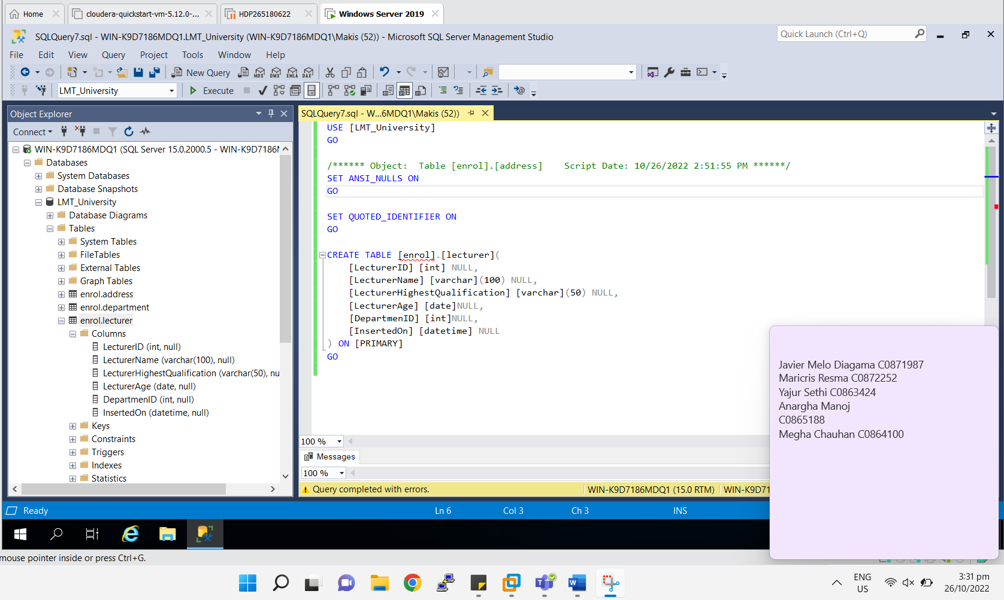

1. Create a “Student” table under “enrol” schema with the following specifications-
   1. Student table Must have the following attributes-

|  |  |  |
| --- | --- | --- |
| **Column Name** | **Data Type** | **Description** |
| StudentID | Integer | Student Unique Identifier |
| StudentFirstName | Varchar | Student First Name |
| StudentLastName | Varchar | Student Last Name |
| StudentDOB | Date | Student Date of Birth |
| StudentMobile | Varchar | Department Unique Identifier |
| StudentRollNo | Integer | Student Roll Number |
| DepartmentID | Integer | Department Unique Identifier |
| AddressID | Integer | Address Unique Identifier |
| InsertedOn | DateTime | Data Insertion Date |

* 1. Add the following constraints-
     1. StudentID: Auto Increment, Primary Key, Not null, clustered index.
     2. StudentFirstName: Not Null
     3. StudentLastName: Null
     4. StudentDOB: Not Null
     5. StudentMobile: Null
     6. StudentRollNo: Not Null
     7. DepartmentID: Foreign key, Not Null.
     8. AddressID: Foreign key, Not Null.
     9. InsertedOn: Not Null
  2. Insert the following records based on the following specifications.
     1. StudentID: Student ID starting from 1 to 50 with step size 1.
     2. StudentFirstName: Insert the Student First Name mentioned in the table.
     3. StudentLastName: Insert the Student Last Name mentioned in the table.
     4. StudentDOB: Insert the Student DOB mentioned in the table.
     5. StudentMobile: Insert the Student Mobile no mentioned in the table.
     6. StudentRollNo: Insert the Student Roll no mentioned in the table.
     7. DepartmentID: Insert the Department ID mentioned in the table.
     8. AddressID: Insert the Address ID mentioned in the table.
     9. InsertedOn: Insert as default date as system date.
  3. After Insertion, Table looks like as shown below-

|  |  |  |  |  |  |  |  |  |
| --- | --- | --- | --- | --- | --- | --- | --- | --- |
| **StudentID** | **StudentFirstName** | **StudentLastName** | **StudentDOB** | **StudentMobile** | **StudentRollNo** | **DepartmentID** | **AddressID** | **InsertedOn** |
| 1 | Joey | Ironside | 1995-11-22 | 1276234258 | 1 | 3 | 1 | 2020-10-01 |
| 2 | Karlotta | Garraway | 1997-07-06 | 2192431615 | 2 | 3 | 24 | 2020-10-01 |
| 3 | Jerry | Stutte | 1996-12-18 | 4125425783 | 3 | 1 | 17 | 2020-10-01 |
| 4 | Yehudit | Rahill | 1995-01-15 | 9939485406 | 4 | 2 | 29 | 2020-10-01 |
| 5 | Cele | Crosetto | 1998-11-24 | 3622733725 | 5 | 3 | 16 | 2020-10-01 |
| 6 | Hazlett | Mowsdale | 1995-04-09 | 1482883476 | 6 | 4 | 23 | 2020-10-01 |
| 7 | Carlyn | Marks | 1996-12-27 | 6129154080 | 7 | 5 | 20 | 2020-10-01 |
| 8 | Ellis | Boatman | 1997-04-29 | 8269707118 | 8 | 6 | 7 | 2020-10-01 |
| 9 | Florina | Boyack | 1997-08-03 | 9623352863 | 9 | 3 | 14 | 2020-10-01 |
| 10 | Borg | Innett | 1997-09-03 | 5256034960 | 10 | 1 | 19 | 2020-10-01 |
| 11 | Sayres | Jennings | 1996-05-12 | 8675076454 | 11 | 4 | 27 | 2020-10-01 |
| 12 | Jarid | Sprull | 1998-11-02 | 1391270091 | 12 | 2 | 6 | 2020-10-01 |
| 13 | Elvera | Bannard | 1996-09-07 | 7897232539 | 13 | 4 | 24 | 2020-10-01 |
| 14 | Ody | Inggall | 1995-03-05 | 6094734260 | 14 | 5 | 25 | 2020-10-01 |
| 15 | Curcio | McWhan | 1996-07-29 | 2394865847 | 15 | 6 | 11 | 2020-10-01 |
| 16 | Connie | Sinnie | 1995-07-19 | 1473936221 | 16 | 6 | 23 | 2020-10-01 |
| 17 | Auroora | Nel | 1996-09-05 | 2216400391 | 17 | 3 | 14 | 2020-10-01 |
| 18 | Wendall | Rosendale | 1999-12-30 | 1818120249 | 18 | 3 | 28 | 2020-10-01 |
| 19 | Hadley | Bradbury | 1996-08-16 | 6518067697 | 19 | 1 | 10 | 2020-10-01 |
| 20 | Celine | Smales | 1999-07-11 | 7106508130 | 20 | 2 | 10 | 2020-10-01 |
| 21 | Jesselyn | Stevenson | 1998-05-16 | 9231672206 | 21 | 2 | 22 | 2020-10-01 |
| 22 | Corinna | Pinkney | 1998-01-16 | 8323630067 | 22 | 5 | 29 | 2020-10-01 |
| 23 | Orelle | Adamthwaite | 1997-07-26 | 2539126766 | 23 | 3 | 17 | 2020-10-01 |
| 24 | Howie | Seaman | 1997-12-01 | 9888259627 | 24 | 2 | 4 | 2020-10-01 |
| 25 | Sibyl | Corey | 1996-07-18 | 4493239590 | 25 | 5 | 11 | 2020-10-01 |
| 26 | Ruperta | Peaker | 1999-05-22 | 5124781263 | 26 | 5 | 4 | 2020-10-01 |
| 27 | Delmer | Roughey | 1995-04-21 | 4175314364 | 27 | 3 | 22 | 2020-10-01 |
| 28 | Gifford | O'Scannill | 1996-10-31 | 3134783726 | 28 | 4 | 22 | 2020-10-01 |
| 29 | Hedy | O'Hone | 1998-03-29 | 7316228047 | 29 | 2 | 17 | 2020-10-01 |
| 30 | Shalna | Hyde-Chambers | 1999-11-23 | 7455116160 | 30 | 5 | 6 | 2020-10-01 |
| 31 | Ferdie | Di Napoli | 1995-01-17 | 1905908693 | 31 | 4 | 30 | 2020-10-01 |
| 32 | Piper | Giacomuzzo | 1998-09-14 | 5499340503 | 32 | 6 | 4 | 2020-10-01 |
| 33 | Gerhardt | Schruurs | 1999-11-18 | 8197494894 | 33 | 3 | 1 | 2020-10-01 |
| 34 | Mellicent | Buncher | 1996-10-03 | 4584525312 | 34 | 5 | 28 | 2020-10-01 |
| 35 | Corette | Demead | 1997-09-17 | 4909862137 | 35 | 5 | 17 | 2020-10-01 |
| 36 | Jorgan | Barson | 1997-05-01 | 6022309183 | 36 | 1 | 21 | 2020-10-01 |
| 37 | Koral | Bowen | 1998-05-12 | 4198817454 | 37 | 4 | 3 | 2020-10-01 |
| 38 | Allissa | Kitter | 1998-08-17 | 7328676920 | 38 | 5 | 7 | 2020-10-01 |
| 39 | Townsend | Doughtery | 1998-04-13 | 2639777958 | 39 | 4 | 7 | 2020-10-01 |
| 40 | Yolane | Geratt | 1998-06-10 | 2069585951 | 40 | 6 | 17 | 2020-10-01 |
| 41 | Chrystel | Allwood | 1996-09-07 | 6958461692 | 41 | 3 | 25 | 2020-10-01 |
| 42 | Dyana | Clutterbuck | 1997-09-22 | 5842483886 | 42 | 1 | 1 | 2020-10-01 |
| 43 | Nikki | Edy | 1999-01-10 | 5096155315 | 43 | 6 | 25 | 2020-10-01 |
| 44 | Hendrik | Surr | 1997-04-05 | 2021255732 | 44 | 5 | 11 | 2020-10-01 |
| 45 | Marta | Bosch | 1998-09-28 | 4075136713 | 45 | 6 | 5 | 2020-10-01 |
| 46 | Garrik | Pell | 1999-04-14 | 3071057649 | 46 | 6 | 7 | 2020-10-01 |
| 47 | Stormi | Colbron | 1998-10-21 | 9968113654 | 47 | 3 | 28 | 2020-10-01 |
| 48 | Angelique | Iacivelli | 1995-06-07 | 9518365081 | 48 | 5 | 7 | 2020-10-01 |
| 49 | Zack | Hefforde | 1999-07-25 | 5455693035 | 49 | 1 | 29 | 2020-10-01 |
| 50 | Gusella | Pettiford | 1999-08-23 | 2425172721 | 50 | 4 | 3 | 2020-10-01 |

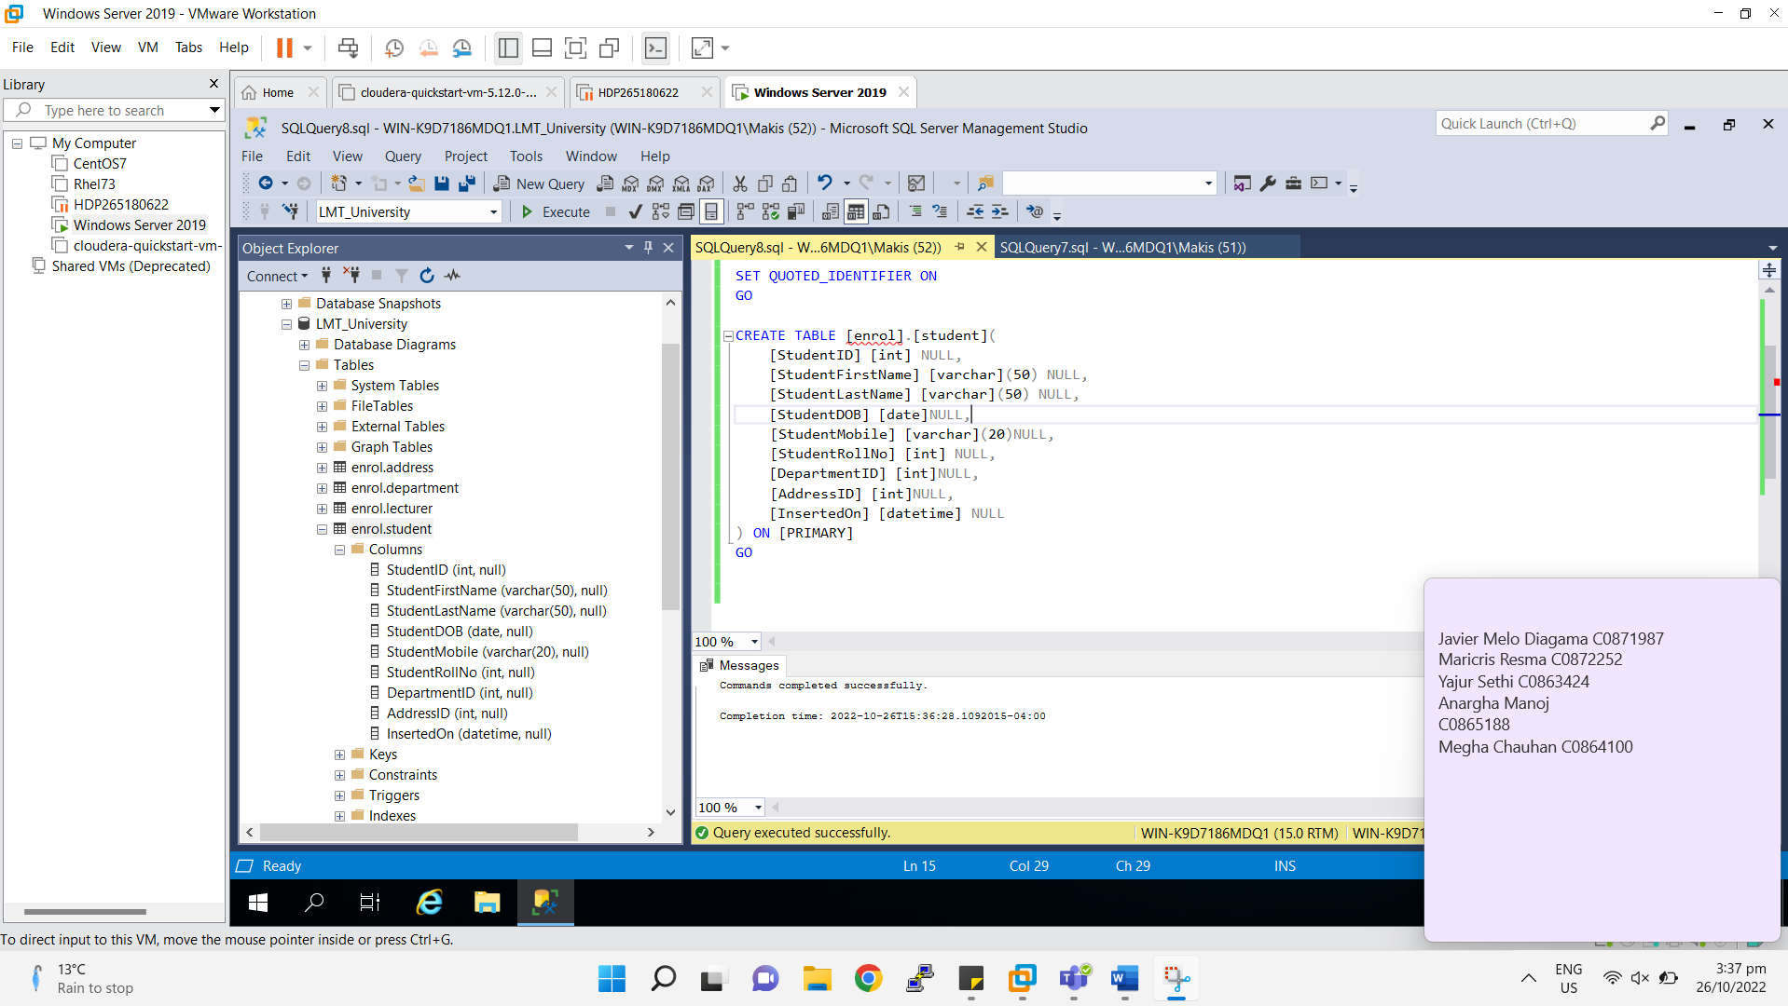

1. Write the following Query based on the above datasets.
   1. List all the Student information from the Student table.
   2. List all the Department information from the Department table.
   3. List all the Lecturer information from the Lecturer table.
   4. List all the Address information from the Address table.
   5. List the StudentFullName, StudentDOB, StudentMobile from Student [StudentFullName=StudentFirstName + ‘ ‘ + StudentLastName]
   6. List the StudentID, StudentFirstName, StudentLastName, StudentDOB, StudentMobile from Student in AddressID 7.
   7. List all the student information whose first name is start with 'B'
   8. List all the student information whose first name is start and end with 'A'
   9. Count the number of Student from Student table whose DepartmentID 6.
   10. List all the StudentFullName, StudentAge, StudentMobile from Student [StudentFullName= StudentFirstName + ‘ ‘ + StudentLastName]

[StudentAge= Current date – DOB (in Years)]

* 1. List all the StudentFullName, StudentAge, StudentMobile whose Age>23 from Student [StudentFullName= StudentFirstName + ‘ ‘ + StudentLastName]

[StudentAge= Current date – DOB (in Years)]

* 1. List all the StudentFullName, StudentAge, StudentMobile whose Age is either 21 or 23 from Student [StudentFullName= StudentFirstName + ‘ ‘ + StudentLastName]

[StudentAge= Current date – DOB (in Years)]

* 1. List all the LecturerID, LecturerName, LecturerHighestQualification, LecturerAge from Lecturer.
  2. List all the LecturerID, LecturerName, LecturerHighestQualification, LecturerAge from Lecturer whose HighestQualification is either “MS” or “PhD”.
  3. List all the lecturer information who belongs to DepartmentID 2.
  4. List all the lecturer information whose name end with “R”.
  5. List all the lecturer information whose name either start or end with “E”.
  6. List all the lecturer name is in capital letter.
  7. Display 5 character from the lecturer name along with LecturerID and LecturerHighestQualification.
  8. List LecturerID, LecturerName, LecturerHighestQualification, LecturerAge(in year) [LecturerAge= Current Date – LecturerAge)] (in year).
  9. List DepartmentID, DepartmentName, DepartmentDescription, DepartmentCapacity from Department.
  10. List all the Department information who’s DepartmentName is “ECE”.
  11. List all DepartmentName, DepartmentDescription, DepartmentCapacity from Department whose capacity is greater than 60.
  12. List all AddressID, StreetAddress, City, State, PostalCode, Country from Address.
  13. List all AddressID, StreetAddress, City, State, PostalCode, Country from Address who belongs to “Poland” country.
  14. List all the Address information whose state is null.
  15. List all the Address information whose PostalCode is not null.
  16. List all the Address information whose City name is "Honda" and Country name is "Colombia"

1. Write the following Query based on the above datasets.
   1. List unique DOB from Student.
   2. List unique DepartmentName from Department.
   3. List unique Country name from Address.
   4. List unique State name from Address.
   5. List unique City name from Address.
   6. List all the LecturerID, LecturerName, LecturerHighestQualification, LecturerYearService from Lecturer [LecturerYearService= Current Date – LecturerAge] (in year).
   7. List all the LecturerID, LecturerName, LecturerHighestQualification, LecturerType from Lecturer [LecturerType= if LecturerYearService< 5 then "Begining Level Experience" else if LecturerYearService>= 5 and LecturerYearService<10 then "Mid Level experience" else "Experienced".
2. Write the following Query based on the above datasets.
   1. Display all Student and their Department Information based on the relationship.
   2. Display all Student and their Address Information based on the relationship.
   3. Display all Department and their Lecturer Information based on the relationship.
   4. Display all Student with their Department with Lecturer Information based on the relationship.
   5. Display all Student with their Address and Department Information based on the relationship.
   6. Display all Student with Address, Department and Lecturer Information based on the relationship.
   7. Display all Student with Address, Department and Lecturer Information who belongs to either “ME” or “ECE” department.
   8. Display Student with Department and their Lecturer information based on the LecturerHighestQualification either “MS” or “PhD”.
   9. Display Student with Department and Address Information, where student belongs to “Thailand” country.
   10. Display Count of Student, Department wise.
   11. Display Count of Lecturer, Department wise.
   12. Display Count of Student, Country wise.
3. Write the following Query based on the above datasets.
   1. Create new table StudCopy and copy all records from Student table.
   2. Create a new table DeptCopy and copy only the schema from Department table.
   3. Create a new table DepartmentCopy and copy all records from Department table.
   4. Create a new table AddrCopy and copy only the schema from Address table.
   5. Create a new table AddrCopy and copy all the records from Address table.
   6. Create a new table LecturerCopy and copy all the records from Lecturer table.
4. Write the following Query based on the above datasets.
   1. Delete all the records from LecturerCopy table.
   2. Delete all the student information for the students who belong to “IT” department.
   3. Delete all the student information for the students who belong to “Indonesia” country.
   4. Delete all the student information for the student who belongs to “Nanshi” city.
   5. Delete all the student information for the student who belongs to “Bretagne” state.
5. Write the following Query based on the above datasets.
   1. Update StudentMobile for those students who belongs to Department “ME”.
   2. Update Student DepartmentID as 3, for the StudentID=42.
   3. Update LecturerHighestQualification as “PHd” for the Lecturer whose LecturerHighestQualification= “PhD”.
   4. Update PostalCode as “00000” for the Address which contain NULL as a PostalCode.
   5. Update StudentLastName as “Paul” for the Student whose Name is “Jerry”.